5th April 2016

**Petr Fulin starts dominating FIA ETCC**

The European Touring Car Cup, which has YOKOHAMA as Official Tyre supplier also inaugurated the new season at the French circuit of Paul Ricard at the weekend.

The Czech driver Petr Fulín made it a clean sweep with a double victory in the first two rounds of the FIA ETCC in the Super 2000 category. With the reverse grid placing Fulin on 8th at the start of race 2, the masterful Czech, quickly weaved his way through on board his TCR 2 spec Seat Leon, overcoming all competitors to cross the chequered flag first. Race 1, with Fulin in P2 meant pole man Rene Munnich had to eventually settle for second place ahead of Peter Rikli in third.

Super 1600 champion Niklas Mackschin on a GMA Autosport Ford Fiesta also took two dominant wins in his class ahead of Andrii Levtushenko and Ulrike Krafft in Race 2. Race 1 had earlier witnessed the German’s hard earned top spot in the podium ahead of Tomáš Korený and Andreas Rinke.

The Automotodrom in Slovakia will see rounds 3 & 4 of the new season from the 15th-17th April.

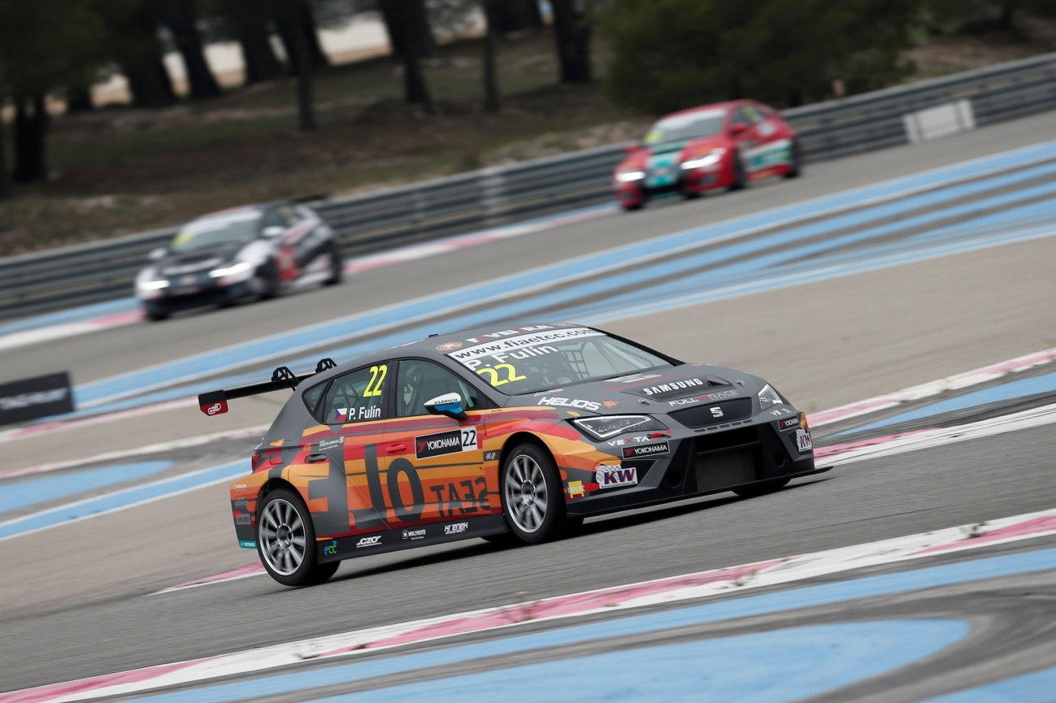

*Petr Fulin Seat Leon 2000 team Krenek motorsport action during the 2016 ETCC - Photo Jean Michel Le Meur DPPI*

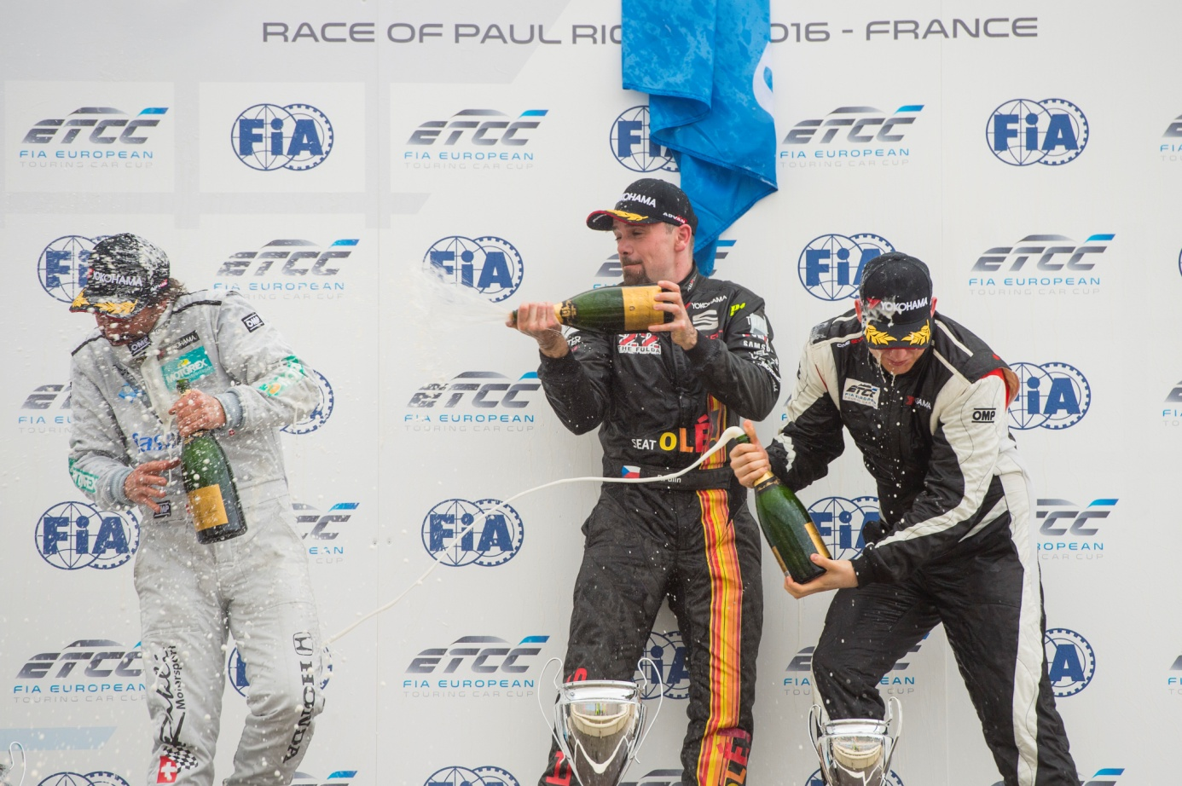

*Petr Fulín* *celebrates victory at FIA ETCC in France*